EXP NO: 4

Strategize impedance matching with characteristic
impedance and load impedance through the
measurement of
a) Location of the stub
b) Length of the stub

Test Case 1:
Optimize impedance matching using single stub matching by finding the location and length of the stub for the values of load impedance of 100 30o to 350 30o keeping the characteristic impedance Zo= 60 Ω constant.
Output:
S.No | (Z_L) (Ω) | Point of attachment (d/\lambda) | Stub length (l/\lambda)
1 | (100\angle30^\circ) | 0.2147 λ | 0.1440 λ
2 | (150\angle30^\circ) | 0.2022 λ | 0.1131 λ
3 | (200\angle30^\circ) | 0.2011 λ | 0.0945 λ
4 | (250\angle30^\circ) | 0.2022 λ | 0.0823 λ
5 | (300\angle30^\circ) | 0.2039 λ | 0.0738 λ
6 | (350\angle30^\circ) | 0.2056 λ | 0.0673 λ

Simulation Result:
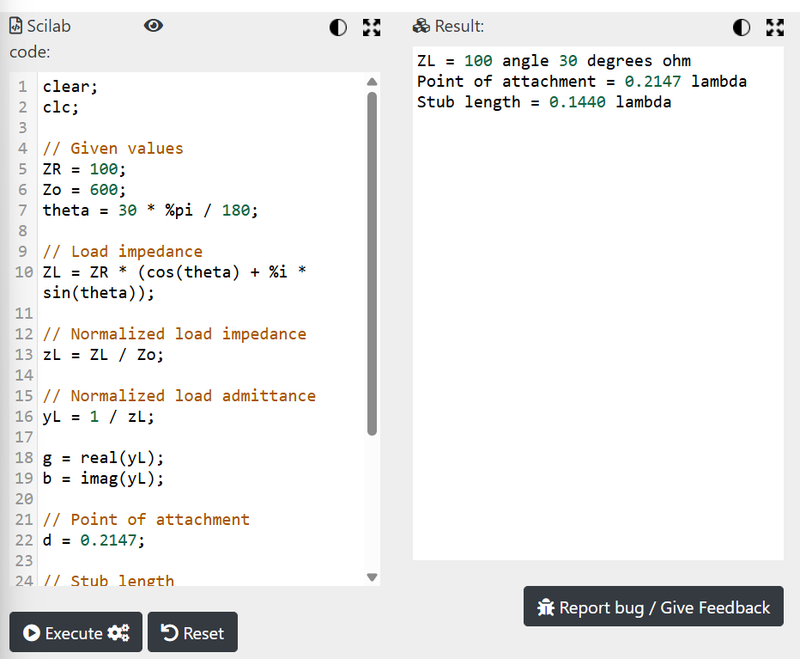
Test Case 2:
Optimize impedance matching using single stub matching by finding the location and length of the
stub for the values of characteristic impedance ranging from 600Ω to 1800 Ω. Keeping the load impedance ZR= 100 constant.
OUTPUT:
Variables Z0;Constants ZR= 100 30oΩ; f=100*(10^6);
S.No | (Z_0) (Ω) | Point of attachment (cm) | Short-circuited stub length (cm)
1 | 600 | 13.22 | 19.87
2 | 800 | 12.13 | 16.83
3 | 1000 | 11.24 | 14.87
4 | 1200 | 10.52 | 13.44
5 | 1400 | 9.92 | 12.36
6 | 1600 | 9.41 | 11.50
7 | 1800 | 8.98 | 10.81
Simulation Result :
